**TINKER V. DES MOINES: THE DECISION**

**Directions: Read the Tinker v. Des Moines majority opinion. Then answer each question below in complete sentences.**

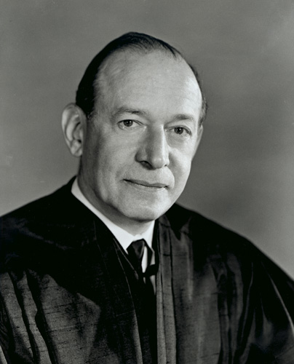*The Court ruled 7 to 2. Justice Fortas (photo to the left) delivered the majority opinion of the Court.*

*Five justices agreed with the* ***majority opinion****. Two justices* ***concurred****, meaning that they agreed with the Court's decision that the school policy was* ***unconstitutional****, but they wrote separately to explain their reasoning. Two justices* ***dissented****. Justice Fortas delivered the majority opinion of the Court, excerpts of which are below:*

. . . First Amendment rights, applied in light of the special characteristics of the school environment, are available to teachers and students. It can hardly be argued that either students or teachers shed their constitutional rights to freedom of speech or expression at the schoolhouse gate. . . .

. . . The 14th Amendment, as now applied to the States, protects the citizen against the State itself and all of its creatures — Boards of Education not excepted. … That they are educating the young for citizenship is reason for […] protection of Constitutional freedoms of the individual, if we are not to strangle the free mind at its source and teach youth to discount important principles of our government as mere platitudes. . . .

**KEY TERMS**

**Majority Opinion**: The decision of more than half of the court and the reasoning behind it; this decision is the ultimate outcome of the case.

**Concurring Opinion**: Judges who agree with the outcome of the case but for different reasons than the majority may write their own opinions.

**Unconstitutional**: Against the principles of the Constitution.

**Dissent**: A legal opinion that goes against the majority opinion of a case.

**Appeal**: To request that a higher court review a lower court’s decision

. . . On the other hand, the Court has repeatedly emphasized the need for affirming the comprehensive authority of the States and of school officials, consistent with fundamental constitutional safeguards, to prescribe and control conduct in the schools. Our problem involves direct, primary First Amendment rights akin to "pure speech."

. . . In order for the State in the person of school officials to justify prohibition of a particular expression of opinion, it must be able to show that its action was caused by something more than a mere desire to avoid the discomfort and unpleasantness that always accompany an unpopular viewpoint. Certainly where there is no finding and no showing that engaging in the forbidden conduct would "materially and substantially interfere with the requirements of appropriate discipline in the operation of the school," the prohibition cannot be sustained . . .

. . . the record fails to yield evidence that the school authorities had reason to anticipate that the wearing of the armbands would substantially interfere with the work of the school or impinge upon the rights of other students . . . [and] the school officials banned and sought to punish petitioners for a silent, passive expression of opinion, unaccompanied by any disorder or disturbance on the part of petitioners. . . .

It is also relevant that the school authorities did not […] prohibit the wearing of all symbols of political or controversial significance . . . Instead, a particular symbol — black armbands worn to exhibit opposition to this Nation's involvement in Vietnam — was singled out for prohibition. Clearly, the prohibition of expression of one particular opinion, at least without evidence that it is necessary to avoid material and substantial interference with schoolwork or discipline, is not constitutionally permissible. In our system, state-operated schools may not be enclaves of totalitarianism. School officials do not possess absolute authority over their students. Students in school as well as out of school are "persons" under our Constitution. In the absence of a specific showing of constitutionally valid reasons to regulate their speech, students are entitled to freedom of expression of their views. . . .

**Questions:**

1. In the majority opinion, the Court recognized the need to balance the specific rights in conflict in this case. What rights are in conflict here?
2. According to the decision, what must a school prove in order to justify a rule prohibiting its students' rights to free speech?
3. Students in the Des Moines schools were permitted to wear other symbols of political statements such as presidential campaign buttons. Why was this significant to the Court?
4. In light of this decision, what are some situations when the Supreme Court of the United States might allow the school district to restrict students' free speech?